**PHASE 2 2:DOCUMENTATION**

**PROJECT:WEBSITE TRAFFIC ANALYSIS**

**INTRODUCTION:**

Since, no one can really look and see the future, how can we then predict website traffic? Well, we can't 100% predict it, BUT, can estimate it by analysing your current website traffic and making some assumptions. And no, you don't always need fancy machine learning models.

**TYPES OF MACHINE LEARNING:**

There are several types of machine learning algorithms that can be used for traffic prediction, Including regression, time-series analysis, and artificial neural network. Regression models use historical traffic data to predict future traffic conditions based on past trends.

**PREDICTING FUTURE WEB TRAFFIC:**

Here the following graph shows the prediction of future web traffic



**STEPS IN MACHINE LEARNING:**

* Problem defining
* Build the dataset
* Train the model
* Evaluate the model
* Implementation

DATASET:

|  |  |  |  |  |  |  |  |
| --- | --- | --- | --- | --- | --- | --- | --- |
| Row | Day | Day.Of.Week | Date | Page.Loads | Unique.Visits | First.Time.Visits | Returning.Visits |
|  |  |  |  |  |  |  |  |
| 1 | Sunday | 1 | 9/14/2014 | 2,146 | 1,582 | 1,430 | 152 |
| 2 | Monday | 2 | 9/15/2014 | 3,621 | 2,528 | 2,297 | 231 |
| 3 | Tuesday | 3 | 9/16/2014 | 3,698 | 2,630 | 2,352 | 278 |
| 4 | Wednesday | 4 | 9/17/2014 | 3,667 | 2,614 | 2,327 | 287 |
| 5 | Thursday | 5 | 9/18/2014 | 3,316 | 2,366 | 2,130 | 236 |
| 6 | Friday | 6 | 9/19/2014 | 2,815 | 1,863 | 1,622 | 241 |
| 7 | Saturday | 7 | 9/20/2014 | 1,658 | 1,118 | 985 | 133 |
| 8 | Sunday | 1 | 9/21/2014 | 2,288 | 1,656 | 1,481 | 175 |
| 9 | Monday | 2 | 9/22/2014 | 3,638 | 2,586 | 2,312 | 274 |
| 10 | Tuesday | 3 | 9/23/2014 | 4,462 | 3,257 | 2,989 | 268 |
| 11 | Wednesday | 4 | 9/24/2014 | 4,414 | 3,175 | 2,891 | 284 |
| 12 | Thursday | 5 | 9/25/2014 | 4,315 | 3,029 | 2,743 | 286 |
| 13 | Friday | 6 | 9/26/2014 | 3,323 | 2,249 | 2,033 | 216 |
| 14 | Saturday | 7 | 9/27/2014 | 1,656 | 1,180 | 1,040 | 140 |
| 15 | Sunday | 1 | 9/28/2014 | 2,465 | 1,806 | 1,613 | 193 |
| 16 | Monday | 2 | 9/29/2014 | 4,096 | 2,873 | 2,577 | 296 |
| 17 | Tuesday | 3 | 9/30/2014 | 4,474 | 3,032 | 2,720 | 312 |
| 18 | Wednesday | 4 | ######## | 4,124 | 2,849 | 2,541 | 308 |

**Program:**

**IN [1]:**

import math

from scipy.stats import norm

import numpy as np

import pandas as pd

import matplotlib.pyplot as plt

from IPython.core.display import HTML

import os

for dirname, _, filenames in os.walk('/kaggle/input'):

for filename in filenames:

print(os.path.join(dirname, filename))

df = pd.read_csv("C:\Users\Sunda\Downloads\daily-website-visitors.csv”)

df.head()

**output:**

**OUT [1]:**

|  |  |  |  |  |  |  |
| --- | --- | --- | --- | --- | --- | --- |
| Row | Day | Day.Of.Week | Date | Page.Loads | Unique.Visits | First.Time.Visits |
| 1 | Sunday | 1 | 9/14/2014 | 2,146 | 1,582 | 1,430 |
| 2 | Monday | 2 | 9/15/2014 | 3,621 | 2,528 | 2,297 |
| 3 | Tuesday | 3 | 9/16/2014 | 3,698 | 2,630 | 2,352 |
| 4 | Wednesday | 4 | 9/17/2014 | 3,667 | 2,614 | 2,327 |

**IN [2]:**

df.plot(figsize=(16,8))

**output 2:**

**OUT [2]:**

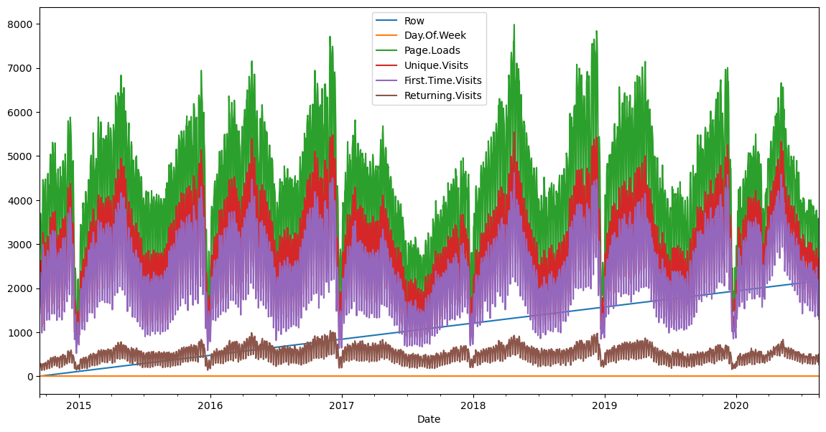

**IN [3]:**

def prob(t, n, lmbda):

return math.pow(lmbda * t, n)/math.factorial(n)*math.exp(-lmbda*t)

mean = df['Page.Loads'].mean()

print( "mean loads per day:", mean)

std = df['Page.Loads'].std()

print( "std deviation of loads per day:", std)

n = 1

px = np.linspace(1, 8000, 50)

py = np.zeros(50)

for i in range(0, 50):

x = (px[i]-mean)/std

p = norm.pdf(x)

py[i] = 1000*p

**OUT [3]:**

mean loads per day: 4116.9893862482695

std deviation of loads per day: 1350.9778426999621

**IN [4]:**

fig, ax1 = plt.subplots()

df['Page.Loads'].plot.hist(ax = ax1, label='Page.Loads')

plt.plot([mean, mean], [0, 480], label='mean')

plt.plot(px, py, label='normal', color='red')

plt.legend()

plt.show()

**OUT [4]:**

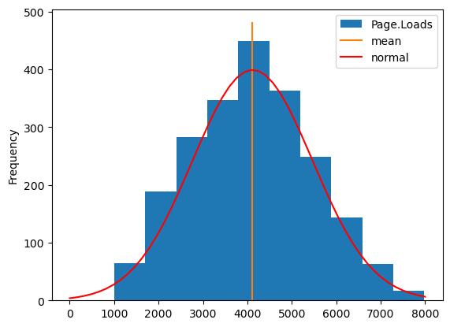

**Conclusion:**

In conclusion, website traffic is a crucial aspect of any online business. By investing in SEO, social media, content marketing, and paid advertising, businesses can attract more visitors to their website and increase brand awareness, lead generation, and search engine rankings.

.

